Richard “Dick” Fitzgerald
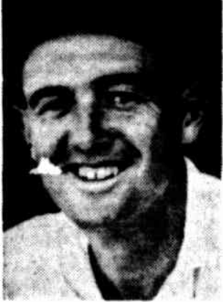
Lake View Cricket Club: 2 x Saturday Turf Association Premierships: 1947-48 & 1948-49.
Goldfields Vs WACA Representative January 1948, April 1949, April 1950.
Took 10 Wickets in the April 1949 Goldfields vs WACA match, 9/28 in the first innings.
A Section Country Week 1949 Competition Best Bowling Average (5.4).
1st Grade Pennant competition player for South Perth (Best Club Bowling Average 1950-51).
Best Bowling Average Lake View & Star Cricket Club (Saturday Turf Association Records) 5.6.
4th Highest Wickets Aggregate Lake View & Star Cricket Club (Saturday Turf Association Records) 103.

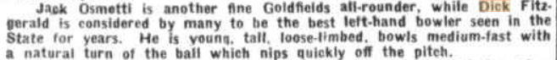

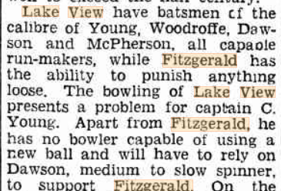
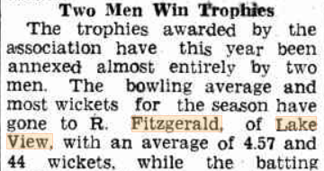
(Note – our wickets tally for R Fitzgerald in this season includes finals wickets as well)
