John Richard Grigg (22 Jan 1904 – 30 Dec 1990)

John Grigg, Front Row, Far Right

(Whilst the photo says it is H Grigg, we believe this is is J Grigg due to the other personnel in the photo – more below).

Born in Geraldton in 1904, Johnny Grigg by the early 1920’s was playing in the WACA colts cricket side & WAFL football for Subiaco (172 Games, Captain 1933, Life member 1973, Premiership Player 1924). W.A state representative in football (1 match). Played for a number of pennant clubs in Perth in both A & B Grade. Renowned for being one of the hardest & cleanest hitters of the ball in metropolitan cricket in Perth during the 1930’s. 2 x LV&S CC premiership player, team member of the 1940 Goldfields Cricket Association country week Boan cup winning side.

Younger brother Harry Grigg played 3 x 1st class matches for Western Australia in 1925-26 (Cap no. 88), having also played cricket for. Harry also represented Western Australia on 10 occassions in interstate football & was a Perth Football Club Life Member & is in their Hall of Fame. Whilst Harry Grigg did play cricket in Kalgoorlie-Boulder in 1937-1938 he had left the region prior to the above photo having been taken (1938-39 LV&S premiership side).

Batting:

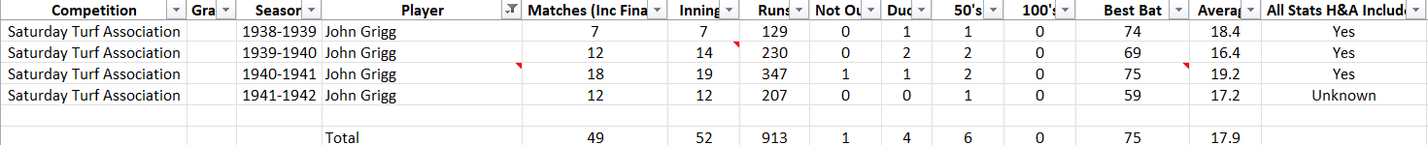

Bowling:



Fielding:





