John (Jack) George Alexander Reece (26 March 1917 – 23 July 1995)
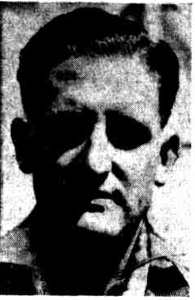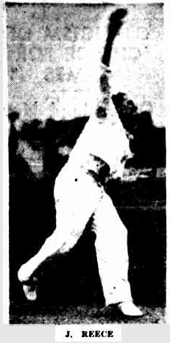
Lake View & Star Cricket Club: 1938-39 & 1940-41.
Jack Reece was born in Adelaide, South Australia in March 1917. By February 1934 he’d made his A Grade debut for Glenelg in the Adelaide District Cricket competition (1st Grade pennant). He’d attended a night bowling school under the tutelage of the great test spin bowler Clarrie Grimmett (still playing tests at this stage 216 wickets, 37 tests – Grimmett is generally regarded as the man who developed the Flipper delivery) & the former test batsman C.E. (Nip) Pellew (10 tests & was the South Australian state coach 1930-WW2 & again between 1958-1970).
By the 1935-36 season he had shifted to the Adelaide suburb of Prospect & had been selected to play for the Colts team in the A Grade where Pellew was his Captain / Coach, another of his team mates in this season being Ron Hamence (3 tests between Feb 1947 & Dec 1948). In his first match he took 5/33 against his former club Glenelg & on the 9th Oct 1935 he dismissed Don Bradman L.B.W for 29 in a one day match against Kensington (on his way to 4/74 – Grimmett who also played for Kensington trumped this with an 8/51 in the Colts innings). In the winter of 1936 he was a member of the South Australian baseball side (playing as a pitcher) that won the Claxton Shield (national baseball carnival – in this year contested between South Australia, N.S.W. & Victoria).
In 1937 he had shifted to Queensland & was playing Baseball for the Valley side in Brisbane. At the start of the 37-38 cricket season he was selected to play A Grade for the Northern Suburbs club in the Queensland Cricket Association & met with great success with the ball, so much so he had come to the attention of the Qld State selectors & Captain Bill Brown (22 Tests for Australia). He was selected for a Qld Metropolis Vs Combined Country match (11/117 for the match) & a Qld Colts Vs N.S.W. Colts match that was considered a trial match for the spinning spot in the Shield side (N.S.W. defeated Qld by an innings & 102 runs & Reece picked up 1/84). By Christmas he was 2nd in the bowling averages in the QCA (33 at 13.9), shifted to Toowoomba & only played another couple of matches for North’s, by the seasons end he still finished 6th in the averages with 36 wickets at 15.11, higher profile victims in the season included Don Tallon (future test keeper) & Rex Rogers a State player that season who headed the batting aggregate with 1213 runs & 4 centuries.
The winter of 1938 saw him playing baseball for the Essendon club in Victoria as well as representing Victoria in the Claxton Shield that season & winning the Lansdown medal for the best player in the Victorian League. By October of 1938 he was in the Goldfields working for the Lake View & Star Mining company as a costing clerk, played 2 games for Lake View in the Saturday Association (top scoring with 71 in his debut with a win against Power Corporation club) & kitted up for Kalgoorlie CC in the GCA (Sunday Turf Association). In December of 1938 he represented Goldfields in a match against Fremantle & took 5/56 off 12 overs. By the seasons end he was a premiership captain with Kalgoorlie in the GCA (with a 10 wicket haul in the grand final), having also taken out the bowling aggregate & average awards (66 wickets at 8.06).
In February of 1940 he was selected as Vice Captain of the Goldfields side that played a South Australian side that had 5 former or current test players in it (as well as a future test player in Reece’s old teammate from the Adelaide Colts side – Ron Hamence – who top scored for S.A. in their first innings with 72) & dismissed Don Bradman for 23 in the first innings - caught & bowled, his figures in the first innings 9-0-67-1. In the GCA he took a further 89 wickets for Kalgoorlie CC at 10.22.
In the 1940-41 season he took another 24 wickets at 13.5 for KCC & played 7 matches for Lake View in the Saturday Turf Association taking 29 wickets @ 8.8. He played in the grand final between LVCC & High School & despite Reece taking 6/39 in High School’s first innings the Viewers lost the match by 77 runs (future W.A. Captain Wally Langdon taking 5/23 & 4/45 for H.S.). By August 1941 he’d enlisted in the R.A.A.F & by 18th Nov 1942 he’d arrived in the U.K. (initially as a Sergeant Pilot & then was commissioned in Sept 1944). He Served with Bomber Command in 158 Squadron flying Handley-Page Halifax Heavy Bombers from RAF Station Lissett (Yorkshire) completing 8 missions before transferring to 466 Squadron & finished the war as an Acting Flight Lieutenant, being discharged 01st August 1946.
Back in Adelaide by 1946 playing Baseball for Kensington, in 1947 he was living in Renmark South Australia & in 1948 represented the Upper Murray Turf Association against a South Australian state side where he was noted as being the outstanding player for the local side. By 1953 it appears he may have been living in Kingscote on Kangaroo Island, if he was then in 1954 he caught an 11ft 1000 pound White Pointer / Great White shark!
Jack Reece passed away 23rd July 1995.
Lake View Cricket Club
9 Matches
11 Innings, 342 Runs, 4 x 50’s, Highest Score 71
33 Wickets @ 10.03, 2 x 5 Wicket Innings, Best Bowling 6/23
2 Catches
Member of 1940-41 LV&S Runner Up Side (EGSTCA).
Qld Sheffield Shield Squad Member 1937-38
Vice Captain of Goldfields side that played South Australia Feb 1940.
Represented South Australia (Claxton Shield winning team member 1936) & Victoria (Lansdown Medal winner – best player in league in 1938 playing for Essendon) in Baseball, playing locally in the Goldfields for South West Boulder (& was instrumental in Goldfields win over W.A. in Sept 1938).
Premiership Captain Kalgoorlie CC (Goldfields Cricket Association – Sunday Turf) 1938-39. Captured 179 wickets in the GCA across 3 seasons.

Lake View & Star CC Batting Stats:
Lake View & Star CC Bowling Stats:
Lake View & Star CC Fielding Stats:

