John (Jack) Morcom Peart 22-Oct-1910 - 17-Mar-2001

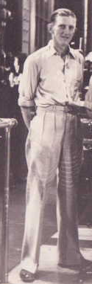 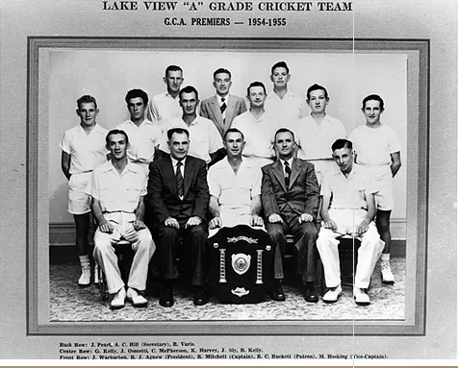

Jack Peart: Top Row, Far Left

Lake View Cricket Club: 1 A Grade Premiership 1954/55.

Career: A Grade: (GCA) 1929-30 – Collegians, 1930-31 – (South West Boulder), 1935-36 (Centrals), 1936-37 (Centrals), 1937-38 (Centrals). B Grade: 1948-49 (Centrals).

1930 & 1938 A Section Country Week Boan Cup Winning Sides (Also a member of the sides that played in the final in 1933, 1934 & 1937, originally named as Captain of the 1950 side (Boan Cup Winning side) though withdrew from that campaign prior to it commencing).

Goldfields Vs WACA Representative Dec 1937, Jan 1948.

Goldfields Vs SACA Representative Feb 1940 (Bradman Match) & Feb 1955.

Scored the first Lake View CC EGCA century.

Lake View Cricket Club Life Member.

Represented Goldfields in Baseball, playing locally for Chaffers.

Lake View Batting Stats:

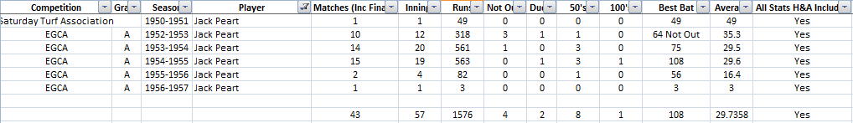

Lake View Bowling Stats:

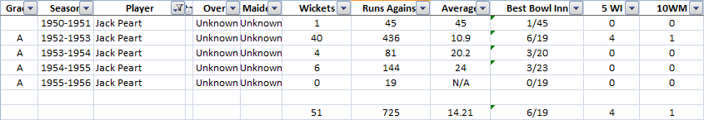

Lake View Fielding Stats:

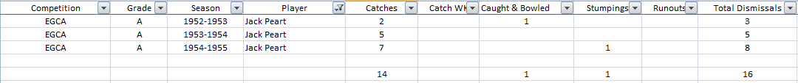

Career GCA/EGCA/Saturday Turf A Grade Stats (Incomplete):



 1995

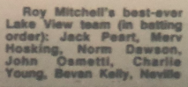

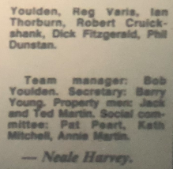



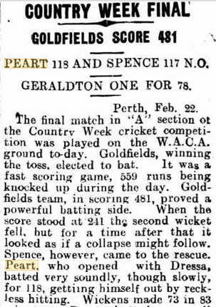

 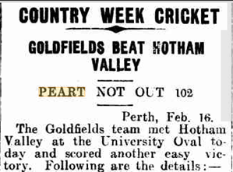

 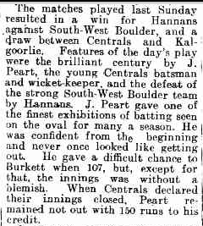

 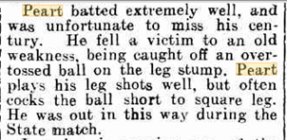



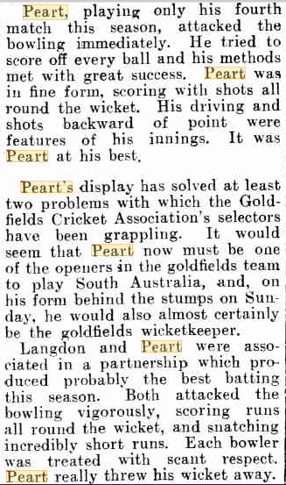

 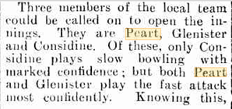

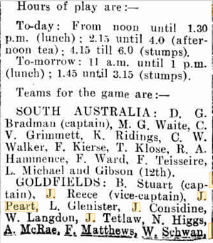

 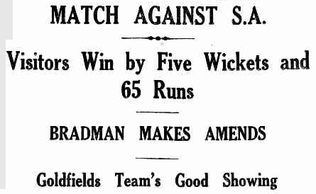

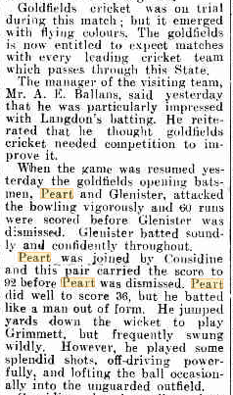 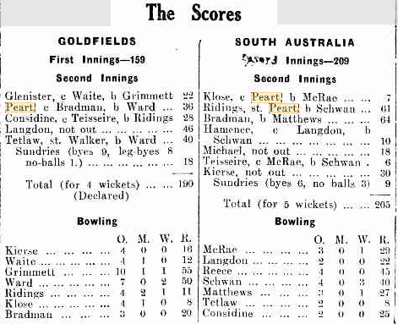



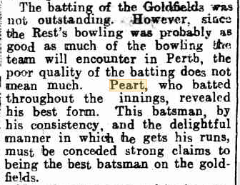

 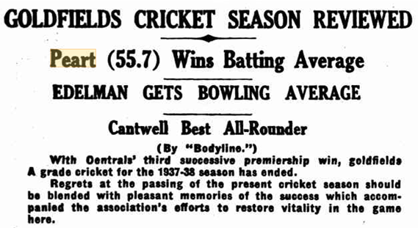

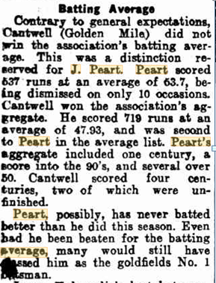 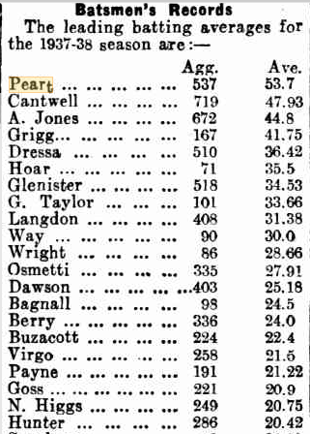

 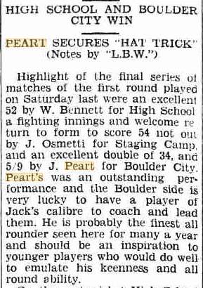

 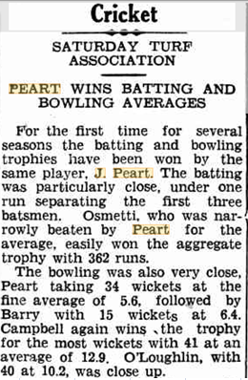



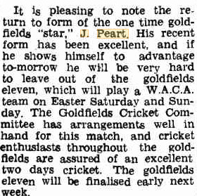



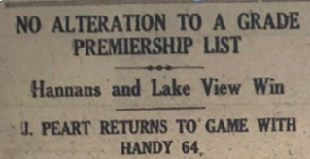

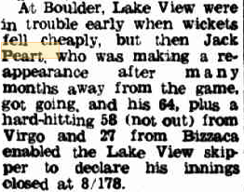



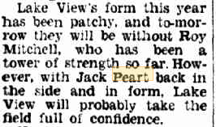



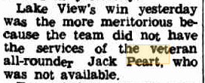

 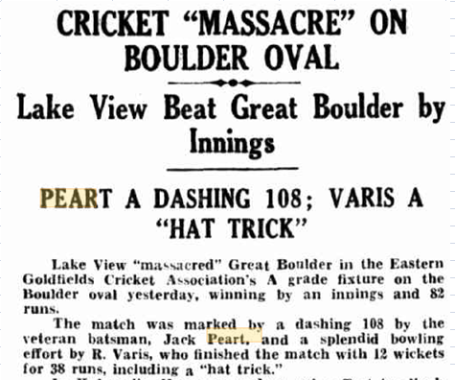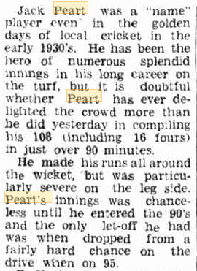



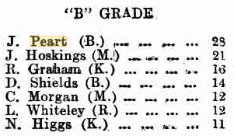

 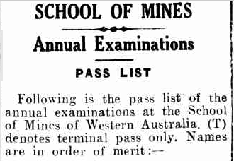

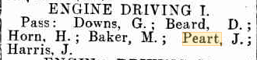

 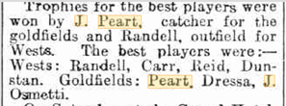



J Peart : 10 WM, 11/65





