2010-2011 EGCA, A Grade Premiership Team, 19-20 March 2011
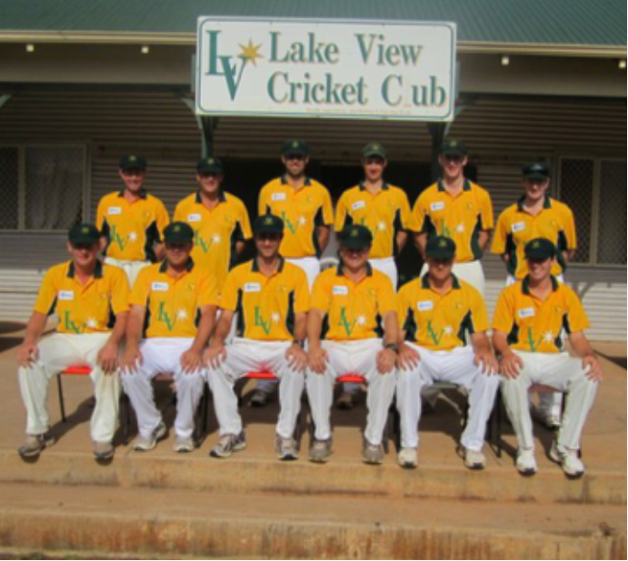
Top L-R: Michael Goss, Matt Gow, Todd Earle, Steve Simpson, Nick Foo, Matt Ruly
Seated L-R: Luke Perry, Ryan Lemm, Zane Arthur, Darren Gaby, Michael Worthington, Josh Rushmore
